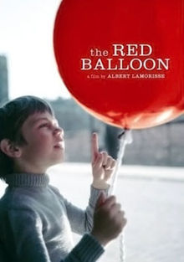
Le ballon rouge noms:

In your group of 3, compare ideas with these questions.
Take turns writing answers so that each person receives the 10-point credit.
S’il vous plaît, create neat and complete sentences for complete credit.

1. How would you describe The Red Balloon to a friend using one or two sentences?

“The Red Balloon” is about

2. What did you like best about The Red Balloon and why? Was is what you had expected?

3. Who were your favorite characters and why? Would you consider the red balloon a
character?

4. Have you ever found friendship or affection in a “thing”?

5. Describe what happens at the end of The Red Balloon.

6. What were some of the ways you used your own imagination in understanding the story?

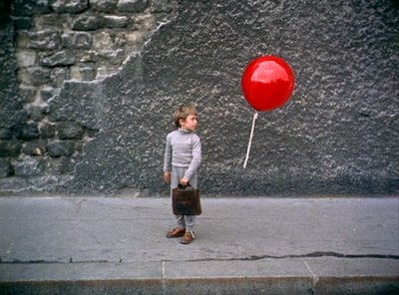
7. Do you think The Red Balloon would appeal to an adult member of your family? Why or why not?

8. How does The Red Balloon connect with Timberlane’s Pillars of Character or Challenge Day?

