Aller et le futur proche Nom: ________________________
page 166 ex 27 – Encerclez les réponses.

1. vais vas va allons allez vont aller
2. vais vas va allons allez vont aller
3. vais vas va allons allez vont aller
4. vais vas va allons allez vont aller
5. vais vas va allons allez vont aller

page 166 ex 28 - Encerclez les réponses.

1. vais vas va allons allez vont aller
2. vais vas va allons allez vont aller
3. vais vas va allons allez vont aller
4. vais vas va allons allez vont aller
5. vais vas va allons allez vont aller

Traduisez – page 167 ex 29 has some helpful phrases.

1. It is snowing. Geraldine is going to ski.

_______________________________________________________________________

2. It is windy; the children are not going to play volley ball at the parc.

_______________________________________________________________________

Because it is windy; they are going to play video games.

_______________________________________________________________________

3. It is raining; you and your cousin are not going to do track.

_______________________________________________________________________

4. It’s bad outside; I am not going to play soccer at the stadium

_______________________________________________________________________

Because it is bad, I am going to play the piano.

_______________________________________________________________________

5. It’s beautiful outside; we are going to make a video in the country.

_______________________________________________________________________

Écrivons: Voilà! #4, c’est un modèle!
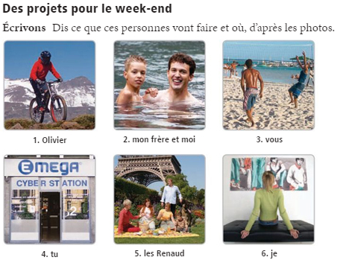
1. Olivier ____________________________________________________________________
2. Mon frère et moi____________________________________________________________
3. Vous______________________________________________________________________
4. Tu vas envoyer des e-mails au cybercafé.
5. Les Renaud________________________________________________________________
6. Je________________________________________________________________________
Bons points :
Comment dit-on « It is going to snow. » _________________________________________

Comment dit-on « It is going to rain. » _________________________________________

