Nos noms: _____________ et ______________

Nos choses à faire
Stamp | Activité
Parler:
Aux partenaires, create a non-scripted conversation that includes…
- asking what do you need for a class
- responding with at least two things you need
- asking if you can borrow one of the two items
- responding
Écrire:
Complete the front side of the “Agreement of Adjectives” handout

Colorier:
read the directions
color the 10 crayons
draw the lignes to the matching object
color the 10 objets aussi

Étudier:
Use the study guide to begin preparing for Friday’s quiz.

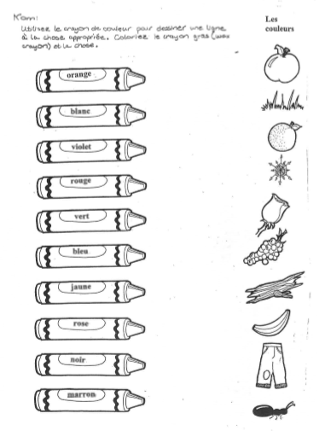

Une fiche de révision
RE verbs :
défendre =
Je | Nous
Tu | Vous
Il/Elle/On | Ils/Elles
Be able to conjugate an RE verb.
Which four boxes have the same sound when pronounced?
to defend
to visit someone
to mow
to lose
to go down
parler =
Je | Nous
Tu | Vous
Il/Elle/On | Ils/Elles
Be able to conjugate an ER verb.
Which four boxes have the same sound when pronounced?

to hear
to wait for
to sell
to answer
to return
Part 1 – Inserting RE Verbs
être =
Je | Nous
Tu | Vous
Il/Elle/On | Ils/Elles

avoir =
Je | Nous
Tu | Vous
Il/Elle/On | Ils/Elles

Given RE verbs, be able to insert the verb in the correct sentence with its correct form.

ex: Les élèves _________________________ le professeur d’EPS. (attendre)
Part 2 – Answering Questions with RE Verbs

Est-ce que tu perds souvent tes devoirs ?

_______________________________________________________________________

Part 3 – Inserting avoir, être, ER, GER, CER verbs into sentences
Nous forms of GER verbs add an _____; nous forms of CER verbs change the c to ___.
Je _____________ maths à midi. | (avoir)
On ______________________ français en France. | (parler)
Les cousines _____________________ gentilles. | (être)
Nous ____________________ le déjeuner. | (manger)
Ma famille et moi ___________________ nos vacances le samedi. | (commencer)
Part 4 – What is the difference in meaning?
Il a un match de base-ball lundi.
Il a un match de base-ball le lundi.
Part 5 – Converting conversational time to l’heure officielle

7:40 am Il est huit heures moins vingt.

l’heure officielle ___________________________________________________

3:55 pm Il est quatres heures moins cinq.

l’heure officielle ___________________________________________________

Part 6 – School Supplies
1. Be able to create a list of les fournitures scolaires that tu as in ton locker.
2. Be able to include un, une or des to indicate gender or quantity.
3. Color vocabulary is not needed for this quiz.

