Mon nom: _________________________________________________

Task : Locate une school from a French-speaking country in order to create a 3D diorama or 3D computer image.

My salle de classe is from the French-speaking country known as

_________________________________________________.

les objets de la classe | Based on my picture, OUI, je can see this or NON, je can’t see this  dans la salle de classe. Looking at another school from this country is a bonne idée (good idea) ! | Check √ cultural artifacts or evidence of climate.
bureau |  | Cultural Evidence  ___ flag  ___ map  ___ posters  ___ books  ___ type of board  ___ language  ___ music  ___ instruments  ___ decor  ___ other…  Climate Evidence  ___ clothing  ___ hats  ___ hairstyle  ___ plants  ___ wall holes  ___ tent netting  ___ other…
cahier
carte
CD/DVD
chaise
crayon
drapeau
élève (student)
fenêtre
feuilles de papier
lecteur de CD/DVD
livre
mobile
ordinateur
portable
porte | oui
poster
prof
pupitre
règle
sac à dos
stylo
table
tableau
télévision

Nom: ___________ Mon projet is due _________
Task: to create a 3D multi-cultural model illustrating typical classroom items

1. Requirements:

- size - no smaller than a shoebox…no larger than what a sixth grader can carry to school

- safe materials – suggested, but not limited to, …cardboard, paper, cloth, wood, clay, scrapbooking, arts/craft items, and various media.

- labels
  - Did you label each item in FRENCH?
  - Did you include each item’s article? Example: une porte
  - Are the labels typed or neatly and clearly written with black marker?
Adding an arrow from the label to the classroom item can help.

- title Une salle de classe de country’s name

- no English anywhere on or in the project; even “by Robert” should be par Robert

2. Advice:

1. Be sure to use more than one photo to confirm a typical classroom.
2. Plan ahead; don’t wait till the last minute.
3. Make a checklist of classroom items to include.
4. Show as much effort as you can.
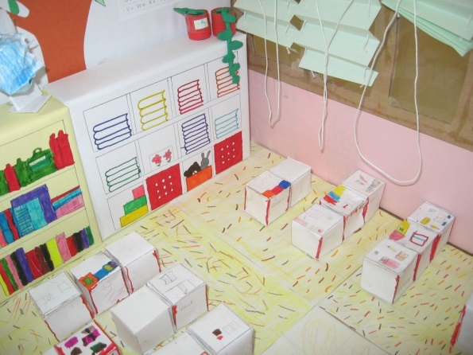
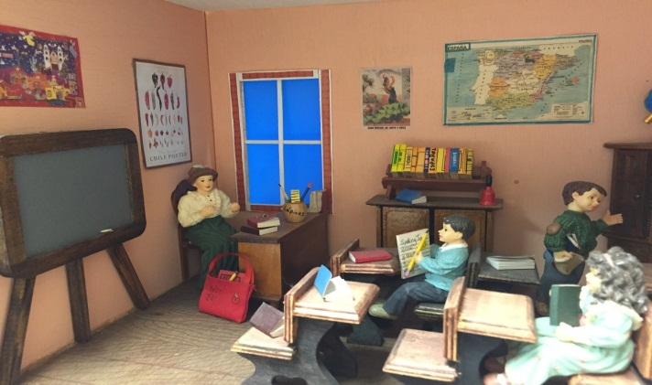

3. Rubric:

CATEGORY | Fantastique! | Bon travail!  Good work! | Pas mal.  Not bad.
Vocabulary | All vocabulary words are used correctly. | 1-2 errors | 3-4 errors | >4 errors
Grammar: un/une articles | Il n’y a pas  d’ erreurs. | 1-2 erreurs | 3-4 erreurs | >4 erreurs
Spelling | Il n’y a pas  d’ erreurs. | 1-2 erreurs | 3-4 erreurs | >4 erreurs
Required Elements:  - Size  - Safe  - Labels  - Title  - No English | All required elements are met;  I have included 3 or more cultural/climate items. | One requirement not met;  2 cultural/climate items included | Does not meet two of the requirements;  has 1 cultural/climate item | More than two of the required elements are missing;  no cultural/climate items are present
Labels, Appearance, Effort | The project’s appearance shows incredible effort. | The project’s appearance shows clear effort. | The project’s appearance shows some effort. | The project’s appearance shows minimal effort.

Notez bien: -5 points per day late
Name ________________ _____/50 points

Comments:

