HOW TO USE VOCAROO

1. Go to
​
http://timberlanefrench.weebly.com/

2. Click on the Resources tab.

3. Click on the Vocaroo image for the link.

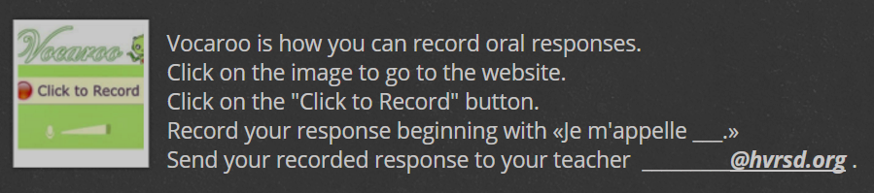

​4. ​Click record.
​​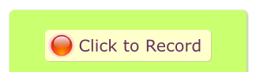

​
5. ​You will see this message; click on Allow.
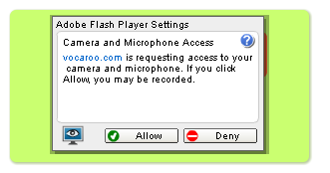
6. Start recording with Je m'appelle your name. Then record your assignment.

7. When complete, click to stop.
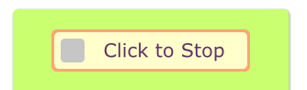

8. You can listen to your recording. If you want to re-do the recording, you can press re-try.

9. When you are happy with the recording, click the Click here to save.​
​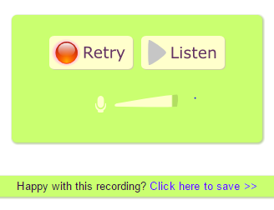

​10. You will see this.
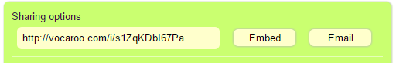

11. Copy the http://vocaroo.com..... link in the Sharing Options box.

12. Paste the http://vocaroo.com..... link in in the assignment. Then I will be able to hear your excellent pronunciation.

