Prénom(s):____________________________
Date:________________
The Euro Quest
_____/10 points
A B C D
Directions:
Use the bag of currency to answer the following:
Look at the euro bills.
List the denominations in order from smallest to largest in size.

Denomination | Color | Front Picture | Back Picture
Describe the architectural pattern from the 5€ to the 500€.

Now, look at the coins.
List the denominations in order from largest to smallest in size.

Denomination  Be sure to include units since some are euros and some are centimes. | Color | Front Picture | Back Picture
How are euro bills and coins very helpful for visually-impaired people?

Noms: __________________________________
_____/10 points
A B C D
- What is the euro? The euro is a type of c_________________.

- What is the symbol of the euro? ________________

- The euro is used on the continent known as ________________.
- How was the euro chosen?

- When did the euro go into official circulation/use? _____________
- Make a list of the countries that use the euro.
Hint: Currently, there are 19 countries = 19 lines

__________________ __________________ _________________
__________________ __________________ _________________
__________________ __________________ _________________
__________________ __________________ _________________
__________________ __________________ _________________
__________________ __________________ _________________
__________________
- Why do so many nations want to have ONE currency?
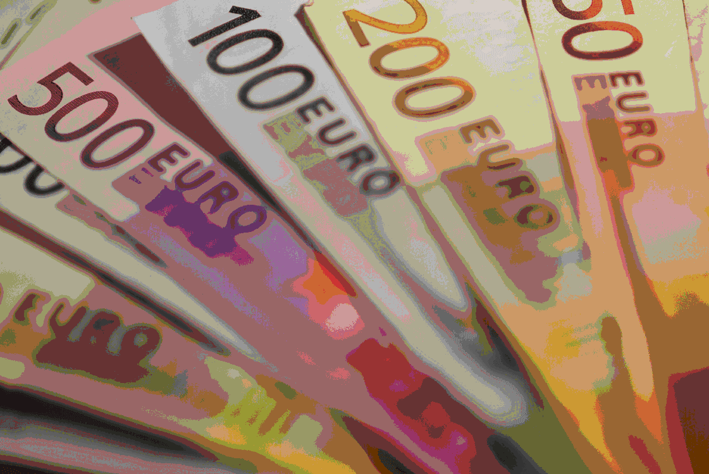

Did all countries adopt the Euro at the same time?

- Which two people designed the Euro?
________________________ and ____________________________

- As of today, what is the current exchange rate from US$ to Euros? 1 euro = $ __________

- Locate a graph that shows the euro’s value over the past 20 years.
  - Circle which year would have been the WORST time to travel.
WORST means it costs more to get a euro.

2001 2004 2008 2012 2015

  - Circle which year would have been the BEST time to travel.
BEST means it costs less to get a euro.

2001 2004 2008 2012 2015

On the front board, look at the French grocery store circular from the summer of 2014. Select two different items and complete the table below based on the sample. Note: 1 kg is about 2.2 pounds.
Pennington ShopRite site
http://plan.shoprite.com/Circular/ShopRite-of-Pennington/99D5682/Weekly/2
Item | French store price in euros  (summer time) | Converted to US dollars | Item price Pennington ShopRite  (spring time)
Nectarine jaune | 1€99 / kg | $2.21/2.2 lbs  $1.00/lb | .99/lb
