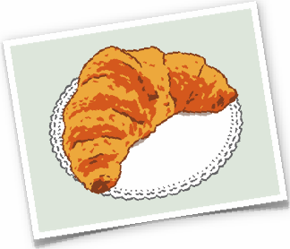
Le croissant

Warm-up Questions

1. What is a traditional breakfast in your country?

2. Do you ever eat croissants?

3. Do you know what the French word “croissant” means?

4. Do you know when and where the first croissants were made?

5. Have you ever heard of “puff pastry”? What do you think it is?

6. Do you know what the Turkish flag looks like?

Croissant is the French word for “crescent.” A croissant is a roll of yeast bread or puff pastry shaped in a curve with pointed ends, like a crescent moon.

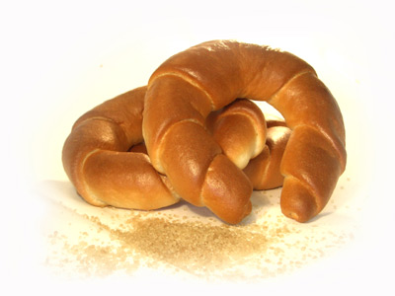
According to a legend, croissants were first made about 1686. Some bakers in Budapest were working at night when they heard noises beneath them. When they investigated the noises, they found that Turkish invaders were digging tunnels under the city walls. The bakers sounded the alarm, the army blew up the tunnels, and the city was saved. As a reward, the bakers were allowed to bake and sell a special pastry to celebrate the victory over the Turks. The pastry was shaped like a crescent moon, which is a symbol on the Turkish flag.

In the mid-1800s, a Viennese bakery had made the famous Kipferl which looks like a croissant. But the French then made a different version that imitated the Kipferl. Croissants were not baked in France, though, for another 200 years. The first recipe for croissants appeared in a French cookbook in 1905. It used pounded almonds and sugar and was more like a heavy bread or cake.

In 1906, the first recipe for the modern croissant showed up in a French cookbook. This recipe used bread dough. A few years later, a French baker decided to make croissants out of puff pastry, which is lighter, flakier dough. The dough is rolled, buttered, and then folded in layers so that it expands when it is baked. In other words, it puffs up. A stick of chocolate or cheese is sometimes added to the dough before it is rolled up and baked.

Before long, the croissant was a national symbol of France, like the Eiffel Tower. The French usually eat them at breakfast, along with coffee and milk (café au lait). They are also cut in half and stuffed with meat or cheese to make a sandwich or eaten like bread with meals.

VRAI ou FAUX

__________1. Croissants originated in France.

__________2. The croissant is a national symbol of Turkey.

__________3. The recipe for croissants has not changed since the 1600s.

__________4. The modern croissant is lighter than the first croissants.

__________5. The first croissants were made to celebrate a military victory.

Works Cited
“Croissants.” 21 April 2013. www.eslemployer.com.

