Cahier d’étude – Indefinite Articles and AVOIR – 40 points

Indefinite articles are un and une meaning a/an and des means some.
Remember that un, une and des change to de or d’ (vowel) when negated with the ne…pas phrase.

Partie 1 – Multiple choice
Be able to select the correct answer to finish the sentence.

1. Dans la classe, il y a _____ élèves.

A. un B. une C. des D. de E. d’

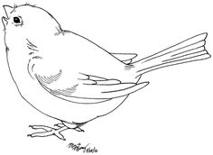
Partie 2 – Completion
Complete a sentence with the appropriate definite article.

2. Tu as _______ oiseau? Non, je n’ai pas ________ oiseau.

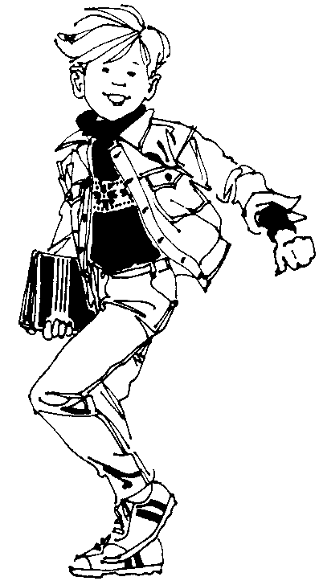
Be sure to know the avoir verb chart.

Partie 3 – Completion
Add the correct form of AVOIR to a sentence.

3. Gérald, il __________ seize ans?

Partie 4 – Creating sentences
You will be given a subject to a sentence.
You will then create your own sentence to describe what they have.
Do not re-use what they might have.

4. Des filles ________________ ______ ___________ et _______ ________.

5. Nous ________________ ______ ________ et _______ ________.
les réponses:
1. C because students is plural and not negated. 2. un (oiseau ends in eau indicating masculine) and d’ (since the sentence is negated and bird begins with a vowel). 3. a (he has is il a) 4. Les filles on des devoirs et un ami. (items change depending on your choices). 5. Nous avons un crayon et des feuilles de papier.

