Une fiche de révision - La culture et les expressions
partie A – VRAI ou FAUX
For this section, study your culture notes from the lesson on:
1. French table manners
2. Comparing the French and American breakfasts

partie B - It’s breakfast time at Olivia’s house. Put Olivia and her mother’s conversation in the most logical order, by numbering the sentences. (Hint: Olivia starts the conversation.)

Studying these expressions on OFFERING, ACCEPTING, and REFUSING food can help.
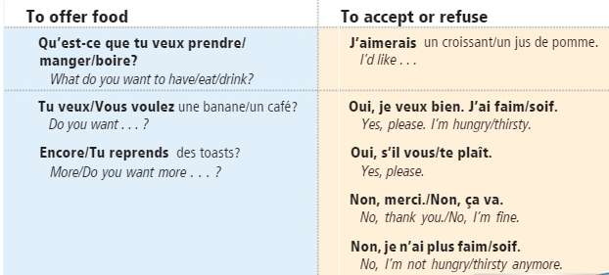

partie C – You will be adding words/phrases in a conversation.
Studying these expressions on ASKING and GIVING OPINIONS can be helpful.
